Data-Driven Analysis of Key Factors Influencing University Students’ Mental Health

Conducted a comprehensive data analysis using Kaggle Public dataset to uncover key determinants affecting university students’ psychological health.

Tools: Excel, Power Pivot, Power Query
Skills: EDA (Exploratory Data Analysis), Data Cleaning, Visualization, Insights Generation

Name: Ariel Wang
Date:23/03/2026

Business Problem
The Psychology Association aims to understand which factors have the greatest impact on university students’ mental health. The central business question is:

As educators, which areas should we focus on to better identify and support students at risk of severe anxiety?

Methodology

Dataset Description
The dataset is sourced from a publicly available Kaggle survey comprising 1,977 anonymized responses from university students in Bangladesh. Each record corresponds to one student’s questionnaire submission and includes:
- demographic attributes: age and gender
- academic information: university, department, academic year, and current CGPA
- financial status: scholarship or tuition waiver
- self-reported assessments of psychological conditions
Students are categorized into different levels of mental health concerns.

Basic integrity checks include:
- validation of score ranges.
- removal of duplicate entries.
- correction of inconsistent data types.
The dataset contains no personally identifiable information, ensuring compliance with privacy and security standards.

Limitations:
- Responses are self-reported, introducing potential bias.
- Sample is restricted to Bangladeshi universities, limiting the generalizability.
- Cultural and academic contexts may differ from other regions.
Despite these constraints, the dataset provides sufficient depth and variability to investigate factors associated with severe anxiety.

Data Wrangling
At the stage of data preparation, a data analyst will check data integrity covering removing duplicate data, outdated data, incomplete data, incorrect data, inconsistent data.
After checking, there are filter issues showing below:
Filter issues:
- This category represents less than 1% of the dataset. Categories below this threshold are considered statistically negligible and do not materially affect distributional patterns or analytical outcomes. It was therefore retained for completeness but excluded from subgroup comparisons where appropriate.
- These categories fall within the 3–5% range, where removal could reduce sample representativeness without providing analytical benefit. Both were preserved as valid categories to maintain the integrity of demographic and academic distributions.
- This is a substantial proportion of the dataset. Removing 8.5% of responses would significantly distort the CGPA distribution and potentially bias the relationship between academic performance and anxiety severity. Preliminary checks confirmed that the anxiety distribution within this group did not exhibit abnormal patterns, supporting its retention as a separate analytical category.
states | filter | count | total respondents | percentage | decision
gender | prefer not to say | 10 | 1977 | 0.51% | retained
department | other | 77 | 1977 | 3.89% | retained
Academic year | other | 71 | 1977 | 3.59% | retained
current CGPA | other | 168 | 1977 | 8.50% | separated category
Table 1. database limitation

Proportional Comparative Analysis & Visualization
Because the number of respondents in different variables is not evenly distributed, raw counts cannot be used for comparison. To ensure statistical fairness, proportional analysis is applied, comparing the percentage of severe-anxiety cases within each subgroup.

Key Findings:
- Count of Anxiety: There are 36% (714) of all students (1977 respondents) identified as severe anxiety, which are obviously higher than other levels of anxiety.
- Age Group: Severe anxiety proportions are similar across 4 age groups (18-22, 23-26, 27-30, above 30), with the 18-22 group slightly higher at 37.08%.
- Gender: The percentage of severe-anxiety cases is higher among females (43.53%) than among males (32.73%), despite males being the larger respondent group.
- University: After categorizing institutions into Engineering & Technology, Comprehensive, and Private universities, 41.27% of students from Engineering & Technology universities reported severe anxiety, the highest proportion among the three groups.
- Department: Business & Entrepreneurship, Engineering & Technology, and Biological Sciences each have a severe anxiety proportion of approximately 36.5%, whereas Environmental & Life Sciences exhibits a noticeably lower proportion (27.66%).
- Academic Year: Second year (40.27%) and third year (41.49%) students exhibit that highest severe-anxiety rates, both well above the overall average of 36.12%.
- CGPA: Severe-anxiety cases are predominantly concentrated in these groups including below 2.50 (43.21%), 2.50-2.99 (39.13%), 3.80-4.00 (37.13%).
- Scholarship Status: Severe anxiety rates are almost the same of the students with scholarships (35.71%) and those without (37.68%).

Core Visualization Examples:

Figure1. Number of Different Levels of Anxiety

Figure 2. Proportion of Severe Anxiety across Age Group

Figure 3. Percentage of Severe Anxiety in Gender Group

Additional charts are provided in 5.3 Appendix B Additional Visualizations.

Inferential Statistical Analysis
To determine which variables most strongly predict severe anxiety, the statistical analysis uses:

Findings & Recommendations
Key insights from the proportional and statistical analyses include:
- Age Group: Although 18-20 group shows a slightly higher proportion of severe anxiety, statistical testing finds no significant association between age and severe anxiety.
- Gender: Severe anxiety is more common among female students than among male students.
- University: Among different institution types, Engineering & Technology universities show the highest proportion of severe-anxiety cases.
- Department: Across academic disciplines, no specific department shows a clear or direct association with severe anxiety.
- Academic Year: Second and third academic year students exhibit the highest proportion of severe anxiety compared with other years.
- CGPA: extreme academic performance levels may also relate to elevated anxiety
- Scholarship Status: Severe-anxiety proportions are similar between students with and without scholarships, suggesting that scholarship status has minimal influence.
Based on key findings, recommendations include:
- As educators,

Next Steps
To

- Appendix

  - Appendix A Data Cleaning & Preparation Details
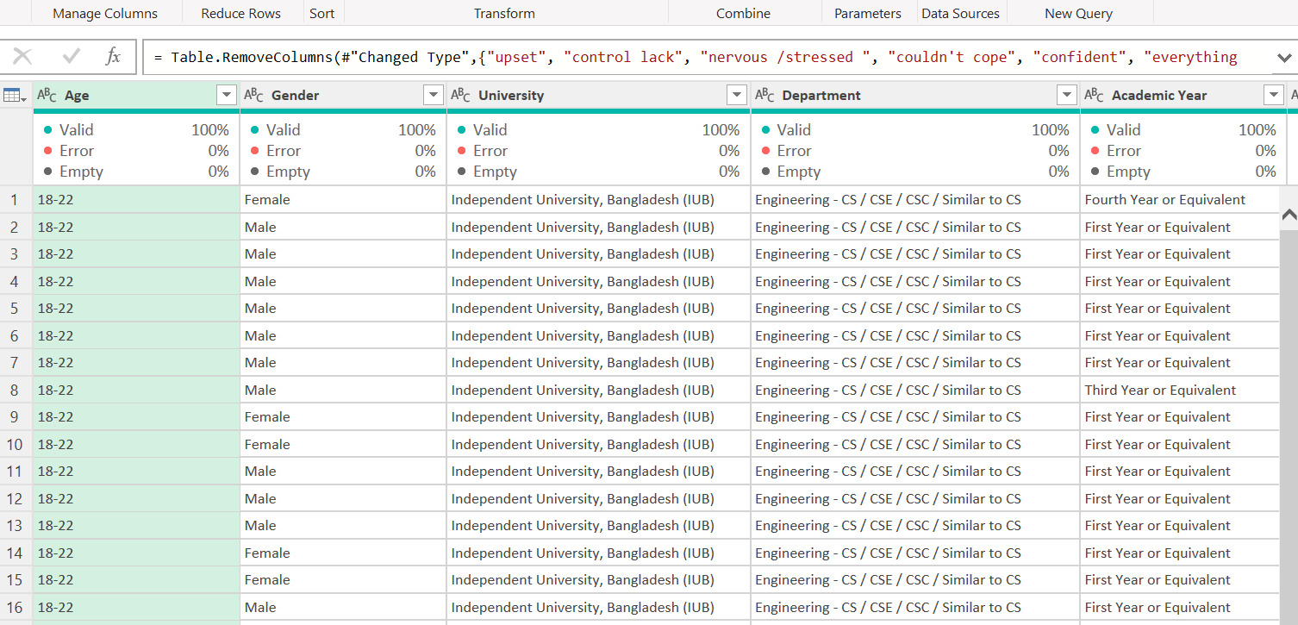
Figure 4.
  - Appendix B Additional Visualizations

  - Appendix C Statistical Tests

